The guide for students- virtual schedules
Welcome to the student guide thanks to which you will have electronic access to your schedule, classrooms, timetable and teachers! Follow the steps which are down below.
- Go to https://warszawa.san.edu.pl
- Click on the Strefa studenta (Student zone)
- Log into the site by using “erasmus” as your login and password. Click Zaloguj (Log into)

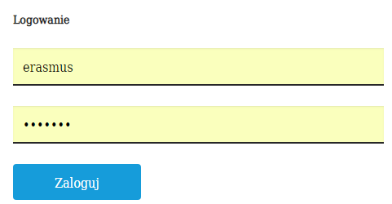

- Look at the menu on your left and click on the Plany zajęć (Schedules)

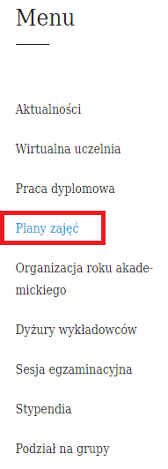
- Click on the banner

- You will be directed to the site https://warszawaa.edupage.org/
- Change the language settings into English by clicking on the right flag in the right top corner
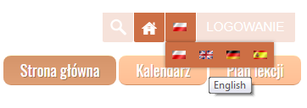
- Click on the Timetable which is on your left
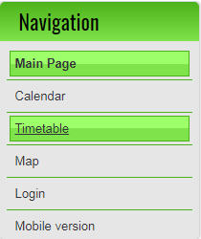

- Now you are able to check your schedule by searching for your subject, group, teacher’s name or classroom.
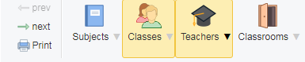

Polish-speaking students coming to Lodz have similar system with the same password and login, but the system is in polish. Students can check their schedules in PDFs. To check it, please visit https://lodz.san.edu.pl/strefa-studenta/strefa-studenta

Remember to check the Student zone regularly since some changes considering the classrooms or cancelled lessons might occur.
In case of any doubts, please contact us by mail- incoming@erasmus.com.pl
Good luck!

